Dimensional Modeling Project: Sales Analysis System

Task 1: Dimension Table Designs

1. DateDim
Purpose: Provides a centralized way to filter and group sales by specific time periods and fiscal cycles.
Attribute | Data Type | Example
DateID (PK) | Integer | 20260309
Date | Date | 09-03-2026
Day | Integer | 9
Month | Integer | 3
MonthName | String | March
Quarter | String | Q1
Year | Integer | 2026
DayOfWeek | String | Monday
IsWeekend | Boolean | False
IsHoliday | Boolean | False
FiscalYear | Integer | 2026

2. CustomerDim
Purpose: Stores demographic and profile information to analyze customer behavior and loyalty.
Attribute | Data Type | Example
CustomerID (PK) | Integer | 5001
CustomerName | String | John
Email | String | john@email.com
Gender | String | male
City | String | Bengaluru
State | String | Karnataka
MembershipLevel | String | Gold
RegistrationDate | Date | 2024-01-15

3. ProductDim
Purpose: Contains all descriptive information regarding items sold for category and brand analysis.
Attribute | Data Type | Example
ProductID (PK) | Integer | 101
ProductName | String | Wireless Mouse
Category | String | Electronics
SubCategory | String | Peripherals
Brand | String | Logitech
UnitPrice | Decimal | 25.00
CostPrice | Decimal | 15.00

4. RegionDim
Purpose: Defines the geographical hierarchy to compare sales performance across different locations.
Attribute | Data Type | Example
RegionID (PK) | Integer | 10
City | String | Bengaluru
State | String | Karnataka
Country | String | India
RegionName | String | South India
PostalCode | String | 560001

5. SalesTeamDim
Purpose: Tracks sales representatives and management structures for performance monitoring.
Attribute | Data Type | Example
SalesTeamID (PK) | Integer | 7
SalesPersonName | String | Nithin G J
TeamName | String | Direct Sales
ManagerName | String | Ashok
OfficeLocation | String | Bengaluru North
HireDate | Date | 2023-06-01

Task 2: SalesTransactionFact Table Design
Attribute | Data Type | Role
SalesTransactionID (PK) | BigInt | Primary Key
DateID (FK) | Integer | Links to DateDim
CustomerID (FK) | Integer | Links to CustomerDim
ProductID (FK) | Integer | Links to ProductDim
RegionID (FK) | Integer | Links to RegionDim
SalesTeamID (FK) | Integer | Links to SalesTeamDim
Quantity | Integer | Measure
UnitPrice | Decimal | Measure (at time of sale)
DiscountAmount | Decimal | Measure
TaxAmount | Decimal | Measure

Calculated Measures:
- Gross Sales: Quantity * UnitPrice
- Net Revenue: (Quantity * UnitPrice) - DiscountAmount
- Total Cost: Quantity * ProductDim.CostPrice
- Gross Profit: Net Revenue - Total Cost

Task 3: Relationship Descriptions
- DateDim -> SalesTransactionFact: One date can have many sales. (1:M). DateDim.DateID connects to Fact.DateID.
- CustomerDim -> SalesTransactionFact: One customer can make multiple purchases. (1:M). CustomerDim.CustomerID connects to Fact.CustomerID.
- ProductDim -> SalesTransactionFact: One product can be sold in many transactions. (1:M). ProductDim.ProductID connects to Fact.ProductID.
- RegionDim -> SalesTransactionFact: One region can host many sales events. (1:M). RegionDim.RegionID connects to Fact.RegionID.
- SalesTeamDim -> SalesTransactionFact: One salesperson can close many deals. (1:M). SalesTeamDim.SalesTeamID connects to Fact.SalesTeamID.

Task 4: Star Schema ERD Structure
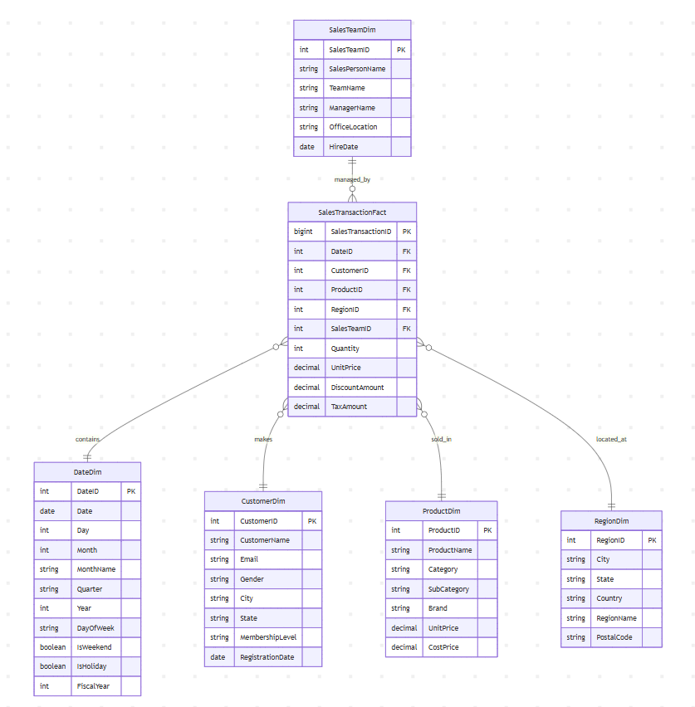

Task 5: Business Question Analysis
- What is the total revenue for Q1 2026?
- Tables Needed: SalesTransactionFact (sum of Net Revenue) and DateDim (filter by Year = 2026 and Quarter = 'Q1').
- Which product had the highest gross profit last month?
- Tables Needed: SalesTransactionFact (calculate Gross Profit), ProductDim (for Product Name), and DateDim (to filter for the previous month).
- Which sales person closed the most deals in South India region?
- Tables Needed: SalesTransactionFact (count of Transaction IDs), SalesTeamDim (for SalesPersonName), and RegionDim (filter by RegionName = 'South India').

